
SSO Application Migration Using Terraform
Aptiv to Versigent Entra ID Tenant
Tool - Terraform IAC.
1.OVERVIEW:
SSO Application Migration Using Terraform
Single Sign-On (SSO) application migration is a critical part of the Aptiv–Versigent Entra ID tenant separation. Terraform, an Infrastructure as Code (IAC) tool, is used to automate the deployment and management of SSO applications in the new Versigent Entra ID tenant. This approach ensures consistency, scalability, and reduced manual effort during the migration process.
Terraform:
Terraform allows you to describe your infrastructure using codes (like servers, networks, databases) in a configuration file, and then it automatically creates or updates those resources for you.
Terraform is an Infrastructure as Code (IAC) software. Terraform is an open-source software created by Hashi Corp.

Purpose of Using Terraform
The key purpose of using Terraform for SSO application migration is to replace manual, UI-based configuration with an automated, code-driven approach. Terraform enables repeatable deployments, minimizes configuration errors, and provides version control for identity configurations.

Terraform in Entra ID:
Declarative configuration files are used by Terraform, an open-source IAC tool, to manage services and infrastructure. Terraform communicates with the AZURE AD provider in the Entra ID context to manage identity resources like:
- Applications
- Users
- Groups
- Assigning Roles
- SSO setups (partial SAML, OIDC/OAuth)

Steps for Installing Terraform:
Download Link: https://developer.hashicorp.com/terraform
User can download the terraform application in Windows or Mac-OS

- Click Install ( Run as Administrator)
- Follow the instructions on screen
- After Completing the setup Click Finish.
- To check the version go to terminal
- Type terraform – version to get the version installed.

Steps to Install and Connect Terraform for SSO Migration
Step 1: Install Terraform
Terraform must be installed on the system where migration will be executed (local machine or CI/CD agent).
Actions: Download Terraform from the official website
Install and verify installation using the Terraform version command
Ensure Terraform is available in the system path
Step 2: Identify Target Entra ID Tenant
SSO applications will be recreated in the target tenant (Versigent).
Actions:
Step 3: Create a Service Principal for Terraform
Terraform requires an identity to authenticate with Entra ID.
Actions:
Step 4: Store Authentication Details Securely
Terraform uses credentials from the Service Principal.
Required values:
Tenant ID
Client ID
Client Secret or Certificate
Step 5: Set Up Terraform Working Directory
Create a dedicated directory for SSO migration.
Actions:
Create a folder for Terraform configuration
Organize files for:
Provider configuration
App registrations
Enterprise applications
Secrets
Step 6: Configure Terraform Provider (AzureAD / Entra ID)
Terraform connects to Entra ID through a provider.
Step 7: Initialize Terraform
Terraform must initialize before any deployment.
Actions:
Step 8: Define SSO Applications as Terraform Code
Step 9: Generate New Secrets for Applications
During migration:
Old secrets from source tenant cannot be reused
Terraform generates new client secrets or certificates
Secrets are marked sensitive
Optional storage in Azure Key Vault
Step 10: Review Terraform Plan
Before deployment, Terraform shows a preview.
Step 11: Apply Terraform Configuration
Step 12: Test SSO Applications
Post-deployment testing is mandatory.
Step 13: Ongoing Management Using Terraform
After migration:
All SSO changes are managed through Terraform
Version control tracks configuration changes
Rollbacks and updates are simplified
Purpose-Terraform becomes the single source of truth

Terraform Workflow ( 3 Core Commands)
- terraform init
Downloads providers and sets up your working directory
- terraform plan
Shows what Terraform will do before doing it.
- terraform apply
Actually deploys the changes to infrastructure.
- destroy
(remove everything)
- validate
(check code)
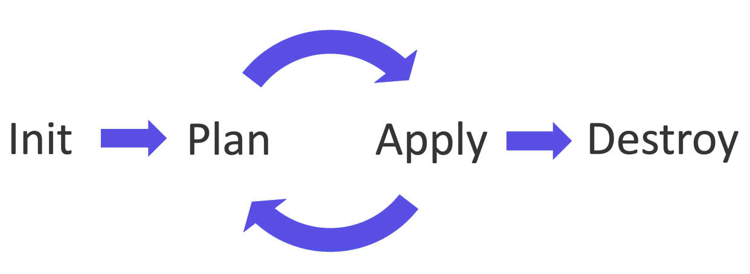

Terraform Main Files

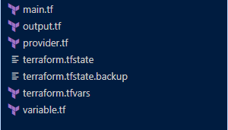

- main.tf
Purpose:
This is the primary configuration file where you define:
Providers (Okta, etc.)
Resources (VMs, Users, Groups, Networks…)
- variables.tf
Purpose:
Contains all input variables used across your Terraform code.
You use this file to:
Make values dynamic
Pass different values for dev/test/prod
- outputs.tf
Purpose:
Defines the outputs Terraform should show after running apply.
Used to display:
IDs, IP addresses, Resource names.
- providers.tf
Purpose:
Separates provider configuration into its own file for clarity

Migration Approach Using Terraform
Converting manually developed resources into code is a necessary step in moving current SSO applications into Terraform.
Methods:
- Import Current Resources
- Use Code to Recreate
- The Hybrid Method
Bring in what is compatible
Manage unsupported characteristics by hand
- Restrictions

How to setup Terraform
Step 1:
Setup Terraform
Install Terraform
Configure AZURE AD provider
provider "azure ad" {}
Step 2:
Create Application
resource "azuread_application" "app" {display name = "my-sso-app"}
Step 3:
Create Service Principal
resource "azuread_service_principal" "sp"
{application_id = azuread_application.app.application_id}
Step 4: Configure Authentication
Step 5:
Assign Users/Groups
resource "azuread_app_role_assignment" "assignment" {
principal_object_id = "<group_or_user_id>"
resource_object_id = azuread_service_principal.sp.object_id
app_role_id = "<role_id>"}
Step 6: Manage Secrets
resource "azuread_application_password" "secret" {application_object_id = azuread_application.app.object_id}

Step 7: Deploy
terraform init
terraform plan
terraform apply
Structure of SSO Applications:
An SSO application in Microsoft Entra ID usually includes:
1. Registration of Applications- specifies the authentication and application identity settings.
2. Principal of Service-restricts access and represents the application instance inside a tenancy.
3. Protocol for Authentication-OIDC/OAuth 2.0 → Used in contemporary applications
For enterprise SaaS integrations, SAML 2.0 is utilized.
4. Group/User Assignment-Decides who has access to the application.
5. Tokens & Claims-specifies the user data that is transmitted to the program.
6. Secrets and Certificates-utilized for safe authentication (signing certificates or client secrets).

LIMITATIONS:
Despite Terraforms strength, using it with Microsoft Entra ID has certain limitations:
- Limited Support for SAML
Complete support for SAML configuration is lacking.
Certain settings need to be manually adjusted.
- Restricted UI-Only Features
Only the portal offers some advanced choices.
- Complexity of Import
Errors can occur when importing pre-existing resources.
requires accurate ID mapping
- Handling Secrets
State files may contain secrets if they are not securely managed.
- API Restrictions

Terraform Supports:
- Identity resource provisioning that is automated
- Identity configuration version control
- Deployments that are repeatable in all environments (dev, test, and production)

CONCLUSION:
Using Terraform to migrate SSO applications provides a structured, automated, and secure approach aligned with modern identity management best practices. This methodology ensures a smooth transition during the Aptiv–Versigent spinoff, reduces operational risk, and establishes a strong foundation for future identity and access management initiatives within the Versigent Entra ID tenant.

